**Testing Result IP2**

**Task 1:** Join a channel: Walk to a planet and touch it for 2 seconds to join. Record success, time, and errors.

**Task 2:** Sit at the long table: Walk to the table and sit. Record data.

**Task 3:** Change seat: Stand up and move to another seat. Record time and success.

**Task 4:** Pick up microphone: Grab the microphone in the middle and check if it can be held. Record success and notes.

**U1**

|  |  |  |  |  |  |
| --- | --- | --- | --- | --- | --- |
| **User ID** | **Task ID** | **Success (Y/N)** | **Errors / Assists** | **Time (s)** | **Observation Notes** |
| 1 | 1 | y | 0 | 11 | Although I explained the task, the user still showed some hesitation when joining the planet (voice channel). |
| 2 | y | 0 | 6 | The participant said that because he was also sitting in real life, he felt very natural and connected when doing Task 2 of sitting at the long table. |
| 3 | y | 0 | 14 |  |
| 4 | y | 0 | 18 | The user tried with both left and right controllers and was very satisfied that both could grab the microphone. |

**SUS**

|  |  |  |  |  |  |  |
| --- | --- | --- | --- | --- | --- | --- |
| **No.** | **Statement** | **1**  **Strongly Disagree** | **2** | **3** | **4** | **5**  **Strongly Agree** |
| **1** | I think that I would like to use this system frequently. |  |  |  | x |  |
| **2** | I found the system unnecessarily complex. |  |  | x |  |  |
| **3** | I thought the system was easy to use. |  |  | x |  |  |
| **4** | I think that I would need the support of a technical person to use this. |  | x |  |  |  |
| **5** | I found the various functions in this system were well integrated. |  |  | x |  |  |
| **6** | I thought there was too much inconsistency in this system. |  | x |  |  |  |
| **7** | I would imagine that most people would learn to use this system quickly. |  |  |  | x |  |
| **8** | I found the system very cumbersome to use. |  | x |  |  |  |
| **9** | I felt very confident using the system. |  |  |  | x |  |
| **10** | I needed to learn a lot of things before I could get going with this. |  | x |  |  |  |

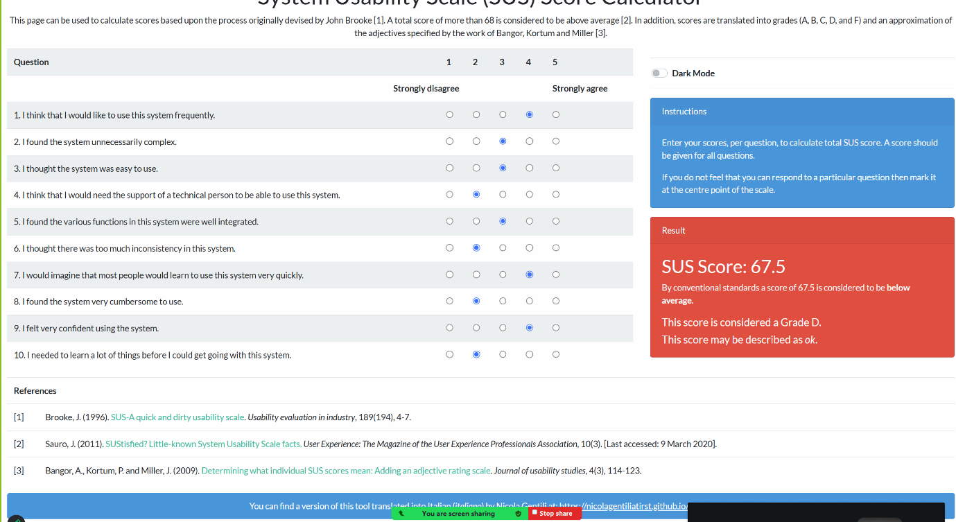

**Open Questions**

**What is one thing you would want me to fix?**

The main thing I want you to fix is the process of entering a planet. I hope it could be changed to remote selection of a planet (voice channel), where the user grabs the one they are interested in, pulls it closer, and after a small visual effect, enters the planet (voice channel). What is one thing you are most satisfied with?

**What is one thing you are most satisfied with?**

Transforming Discord’s voice channels into planets in a galaxy, along with the idea of rotating them, is very attractive.

**U2**

|  |  |  |  |  |  |
| --- | --- | --- | --- | --- | --- |
| **User ID** | **Task ID** | **Success (Y/N)** | **Errors / Assists** | **Time (s)** | **Observation Notes** |
| 2 | 1 | y | 0 | 8 | The participant completed this task smoothly. |
| 2 | y | 0 | 7 |  |
| 3 | y | 1 | 21 | Participant feels a bit dizzy, when she was doing this task. |
| 4 | y | 0 | 15 | The participant tested grabbing the microphone more than once, as if checking its reliability, which shows interest in the object’s function. |

**SUS**

|  |  |  |  |  |  |  |
| --- | --- | --- | --- | --- | --- | --- |
| **No.** | **Statement** | **1**  **Strongly Disagree** | **2** | **3** | **4** | **5**  **Strongly Agree** |
| **1** | I think that I would like to use this system frequently. |  |  | x |  |  |
| **2** | I found the system unnecessarily complex. |  |  |  | x |  |
| **3** | I thought the system was easy to use. |  | x |  |  |  |
| **4** | I think that I would need the support of a technical person to use this. |  |  | x |  |  |
| **5** | I found the various functions in this system were well integrated. |  |  | x |  |  |
| **6** | I thought there was too much inconsistency in this system. |  |  | x |  |  |
| **7** | I would imagine that most people would learn to use this system quickly. |  |  | x |  |  |
| **8** | I found the system very cumbersome to use. |  |  |  | x |  |
| **9** | I felt very confident using the system. |  | x |  |  |  |
| **10** | I needed to learn a lot of things before I could get going with this. |  |  |  | x |  |

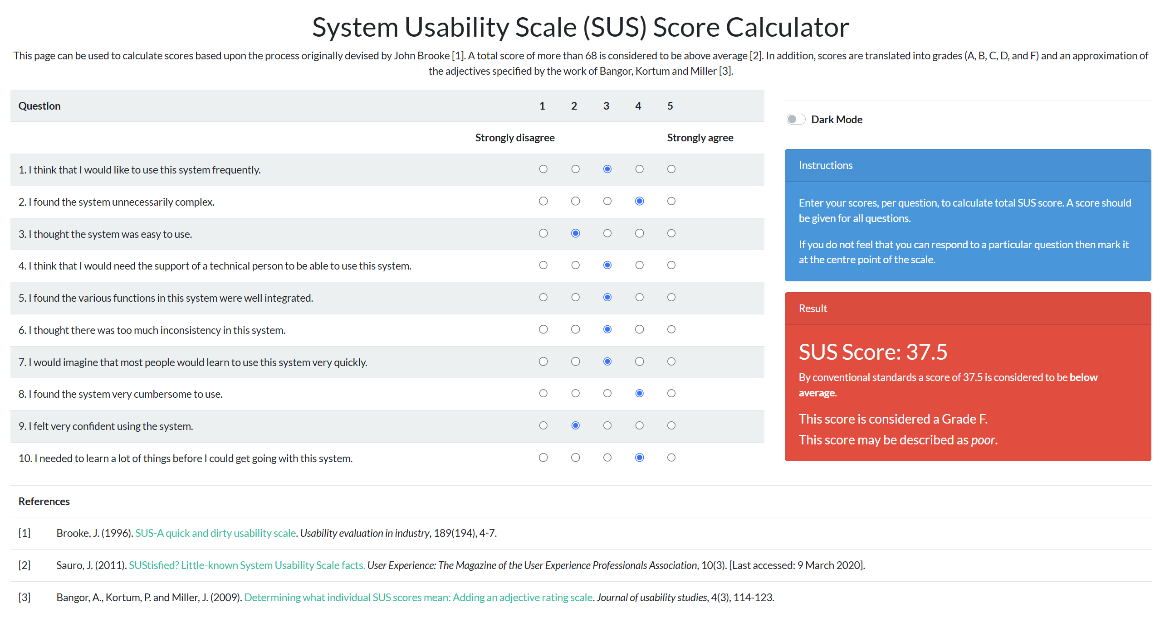

**Open Questions**

**What is one thing you would want me to fix?**

I hope you can change the long table into several smaller tables, so that it shows the idea of only needing to communicate with the people sitting at the same table.

**What is one thing you are most satisfied with?**

I am most satisfied with the interaction of selecting a planet to enter, as it feels very interesting.

**U3**

|  |  |  |  |  |  |
| --- | --- | --- | --- | --- | --- |
| **User ID** | **Task ID** | **Success (Y/N)** | **Errors / Assists** | **Time (s)** | **Observation Notes** |
| 3 | 1 | y | 0 | 9 |  |
| 2 | y | 0 | 9 | The participant paused briefly when entering a new scene, as if searching for cues, which suggests that on-screen text or hints could improve clarity. |
| 3 | y | 0 | 13 | While completing the seating task, the participant moved directly without hesitation, indicating that this action was already clear enough without extra guidance. |
| 4 | y | 0 | 14 | The participant smiled when picking up the microphone, showing that the interaction felt natural and realistic. |

**SUS**

|  |  |  |  |  |  |  |
| --- | --- | --- | --- | --- | --- | --- |
| **No.** | **Statement** | **1**  **Strongly Disagree** | **2** | **3** | **4** | **5**  **Strongly Agree** |
| **1** | I think that I would like to use this system frequently. |  |  |  | x |  |
| **2** | I found the system unnecessarily complex. | x |  |  |  |  |
| **3** | I thought the system was easy to use. |  |  | x |  |  |
| **4** | I think that I would need the support of a technical person to use this. |  | x |  |  |  |
| **5** | I found the various functions in this system were well integrated. |  |  | x |  |  |
| **6** | I thought there was too much inconsistency in this system. |  | x |  |  |  |
| **7** | I would imagine that most people would learn to use this system quickly. |  |  |  |  | x |
| **8** | I found the system very cumbersome to use. |  | x |  |  |  |
| **9** | I felt very confident using the system. |  |  |  | x |  |
| **10** | I needed to learn a lot of things before I could get going with this. |  | x |  |  |  |

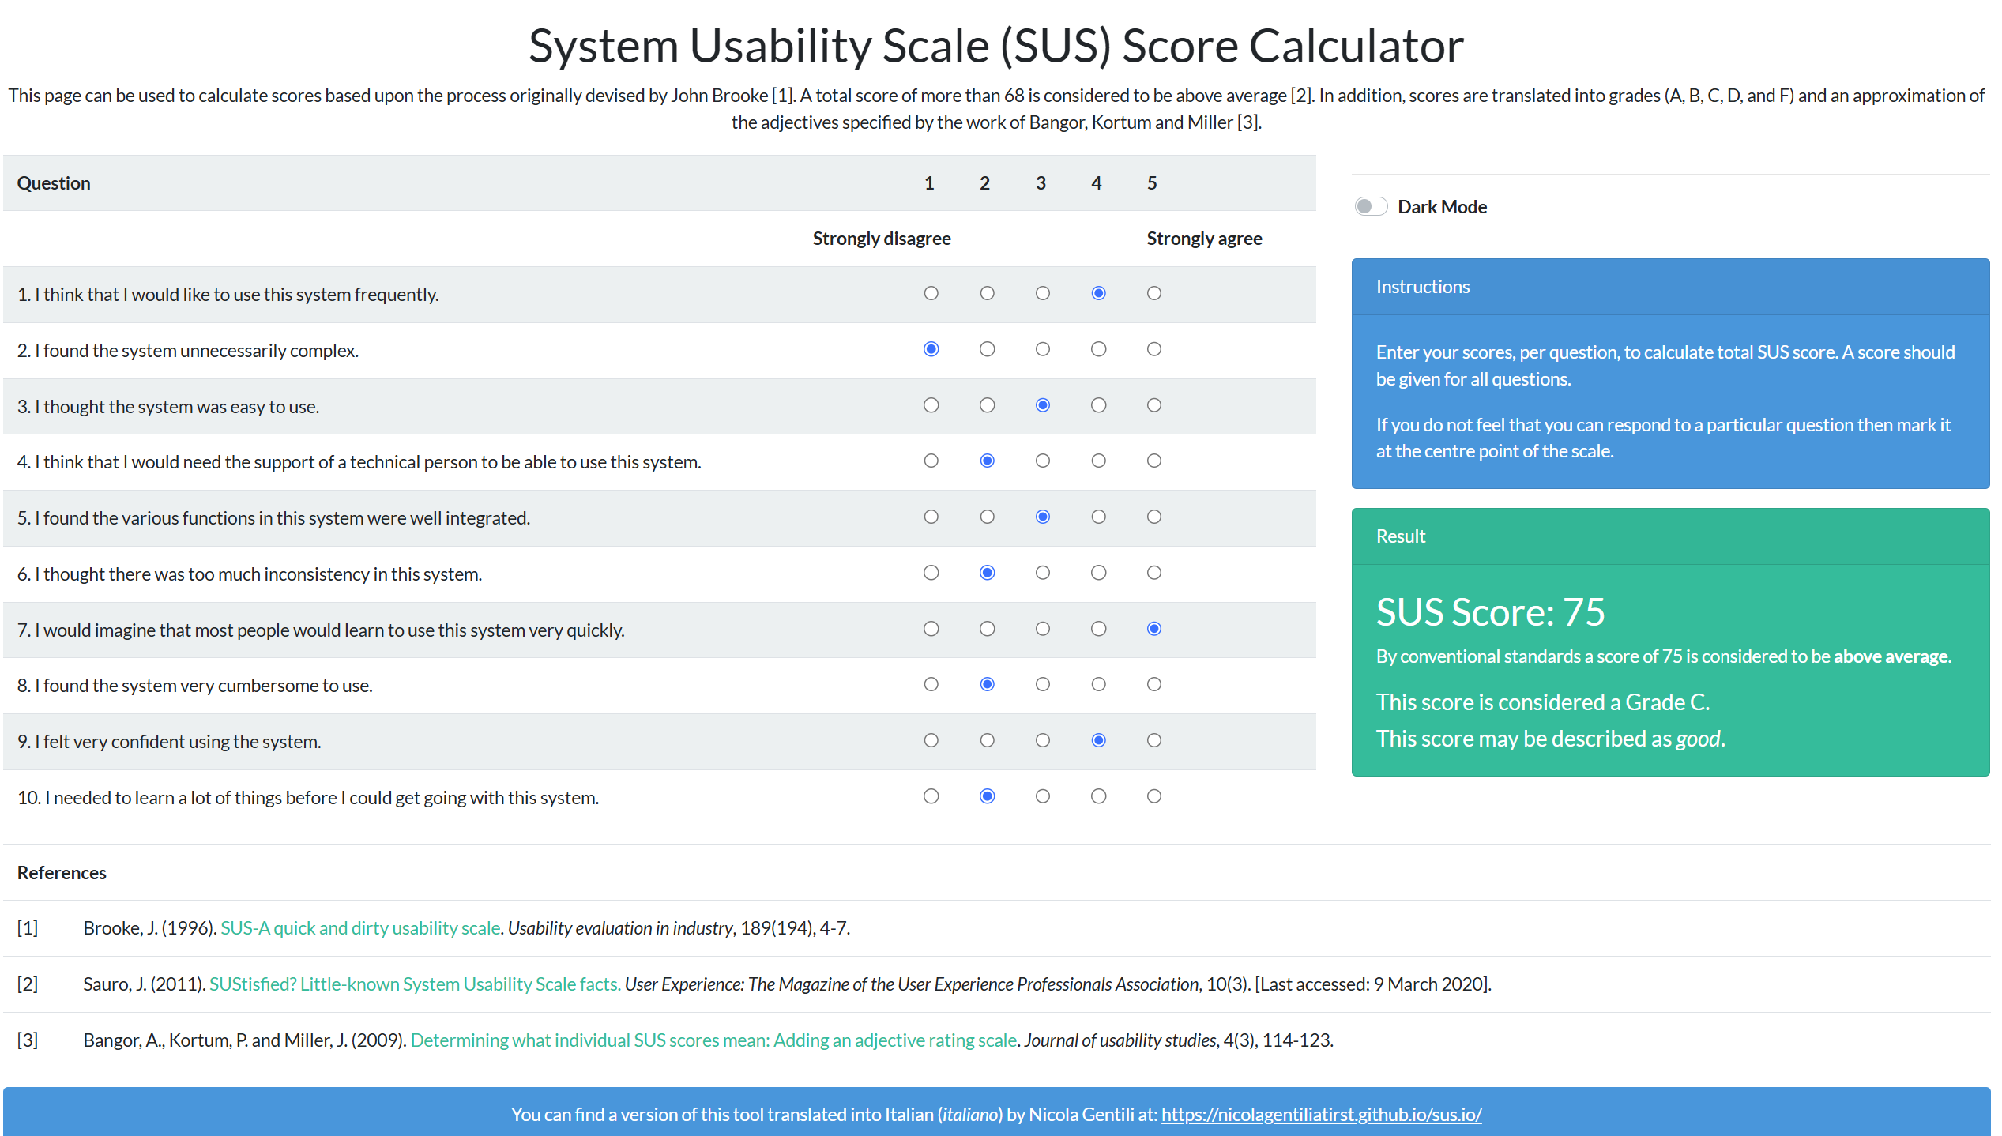

**Open Questions**

**What is one thing you would want me to fix?**

The most important change would be to add hints or prompts in each scene, which can make every task clearer.

**What is one thing you are most satisfied with?**

I am most satisfied with picking up the microphone, as it feels very similar to a real-life situation.

**U4**

|  |  |  |  |  |  |
| --- | --- | --- | --- | --- | --- |
| **User ID** | **Task ID** | **Success (Y/N)** | **Errors / Assists** | **Time (s)** | **Observation Notes** |
| 4 | 1 | y | 1 | 16 | The participant tried 2 times before joining the planet, suggesting that clearer entry instructions might reduce confusion. |
| 2 | y | 0 | 7 |  |
| 3 | y | 0 | 12 |  |
| 4 | y | 0 | 13 |  |

**SUS**

|  |  |  |  |  |  |  |
| --- | --- | --- | --- | --- | --- | --- |
| **No.** | **Statement** | **1**  **Strongly Disagree** | **2** | **3** | **4** | **5**  **Strongly Agree** |
| **1** | I think that I would like to use this system frequently. |  |  |  | x |  |
| **2** | I found the system unnecessarily complex. | x |  |  |  |  |
| **3** | I thought the system was easy to use. |  |  |  | x |  |
| **4** | I think that I would need the support of a technical person to use this. |  |  |  | x |  |
| **5** | I found the various functions in this system were well integrated. |  |  |  |  | x |
| **6** | I thought there was too much inconsistency in this system. | x |  |  |  |  |
| **7** | I would imagine that most people would learn to use this system quickly. |  |  |  |  | x |
| **8** | I found the system very cumbersome to use. | x |  |  |  |  |
| **9** | I felt very confident using the system. |  |  |  |  | x |
| **10** | I needed to learn a lot of things before I could get going with this. | x |  |  |  |  |

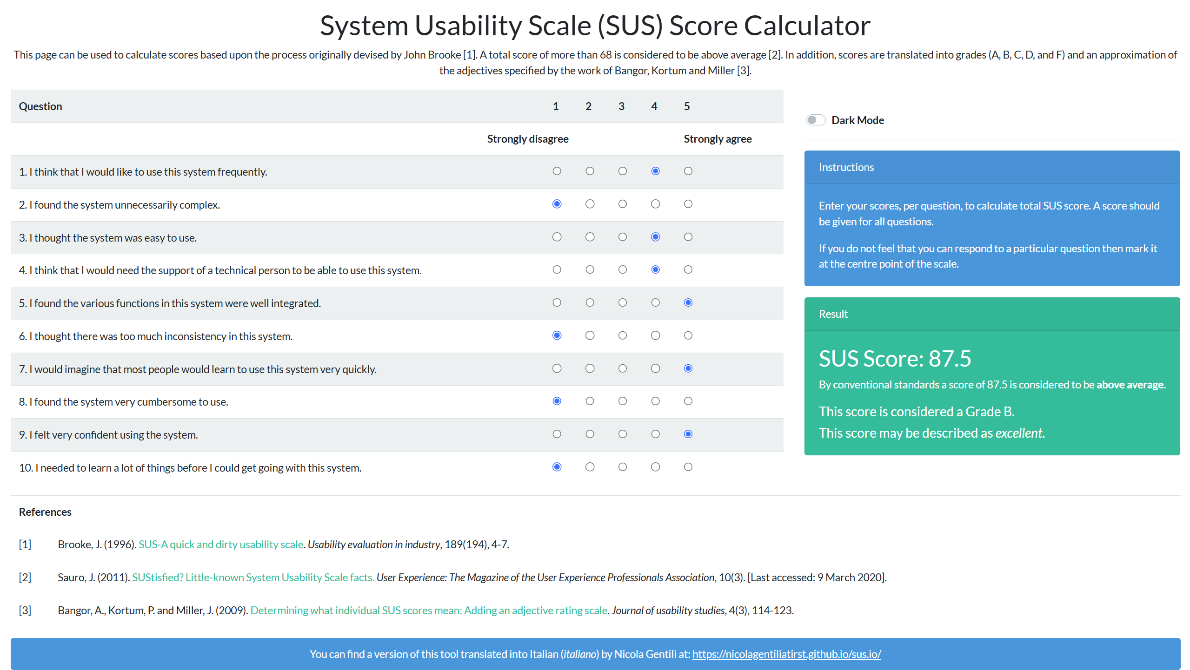

**Open Questions**

**What is one thing you would want me to fix?**

The thing I want you to fix is the process of entering a planet. Without clear prompts or instructions, it feels a bit difficult to know exactly how to join the channel. Sometimes I had to try more than once before being sure that I was doing it correctly. Adding small text reminders or visual feedback would make this step easier and more comfortable for new users.

**What is one thing you are most satisfied with?**

I am most satisfied with the experience of picking up the microphone. It feels very natural and close to how objects behave in real life. Holding it in my hand gave me the sense of actually being in a meeting space, which made the whole XR environment more immersive and realistic.

**U5**

|  |  |  |  |  |  |
| --- | --- | --- | --- | --- | --- |
| **User ID** | **Task ID** | **Success (Y/N)** | **Errors / Assists** | **Time (s)** | **Observation Notes** |
| 5 | 1 | y | 0 | 9 |  |
| 2 | y | 0 | 6 |  |
| 3 | y | 0 | 23 | During task 3, the participant expected to have more seating options. |
| 4 | y | 0 | 15 | The participant experimented with both hand gestures and controllers to grab the microphone, showing curiosity and satisfaction with the flexible interaction design. |

**SUS**

|  |  |  |  |  |  |  |
| --- | --- | --- | --- | --- | --- | --- |
| **No.** | **Statement** | **1**  **Strongly Disagree** | **2** | **3** | **4** | **5**  **Strongly Agree** |
| **1** | I think that I would like to use this system frequently. |  |  |  |  | x |
| **2** | I found the system unnecessarily complex. | x |  |  |  |  |
| **3** | I thought the system was easy to use. |  |  |  |  | x |
| **4** | I think that I would need the support of a technical person to use this. |  |  | x |  |  |
| **5** | I found the various functions in this system were well integrated. |  |  |  |  | x |
| **6** | I thought there was too much inconsistency in this system. | x |  |  |  |  |
| **7** | I would imagine that most people would learn to use this system quickly. |  |  |  |  | x |
| **8** | I found the system very cumbersome to use. | x |  |  |  |  |
| **9** | I felt very confident using the system. |  |  |  |  | x |
| **10** | I needed to learn a lot of things before I could get going with this. |  | x |  |  |  |

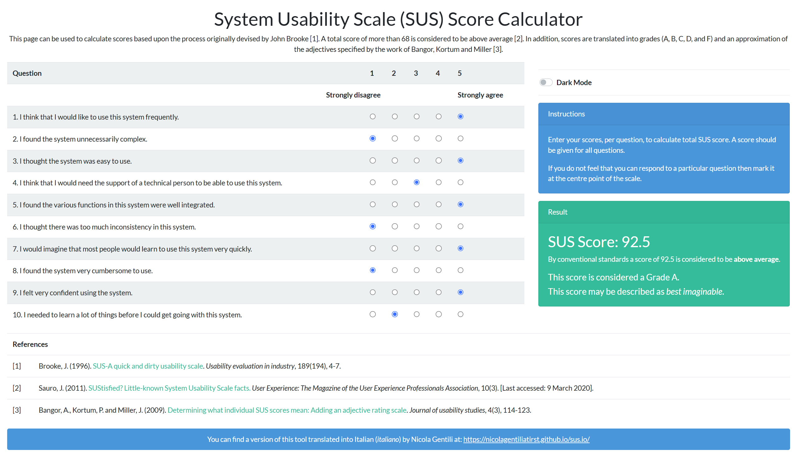

**Open Questions**

**What is one thing you would want me to fix?**

The main improvement I would like to see is the ability to sit on the opposite side of the long table. At the moment, seating feels limited to one side, which makes the space less flexible. Allowing users to freely choose either side would make the interaction feel more natural, give more variety to the experience, and better reflect how people arrange themselves around real tables.

**What is one thing you are most satisfied with?**

I am most satisfied with the microphone interaction, especially that it works with both hand gestures and the controllers. This gave me more freedom to interact in the way I preferred, and it made the experience feel more realistic. Having multiple input options also increased my confidence in using the system because I knew I could rely on different methods if one did not work as expected.